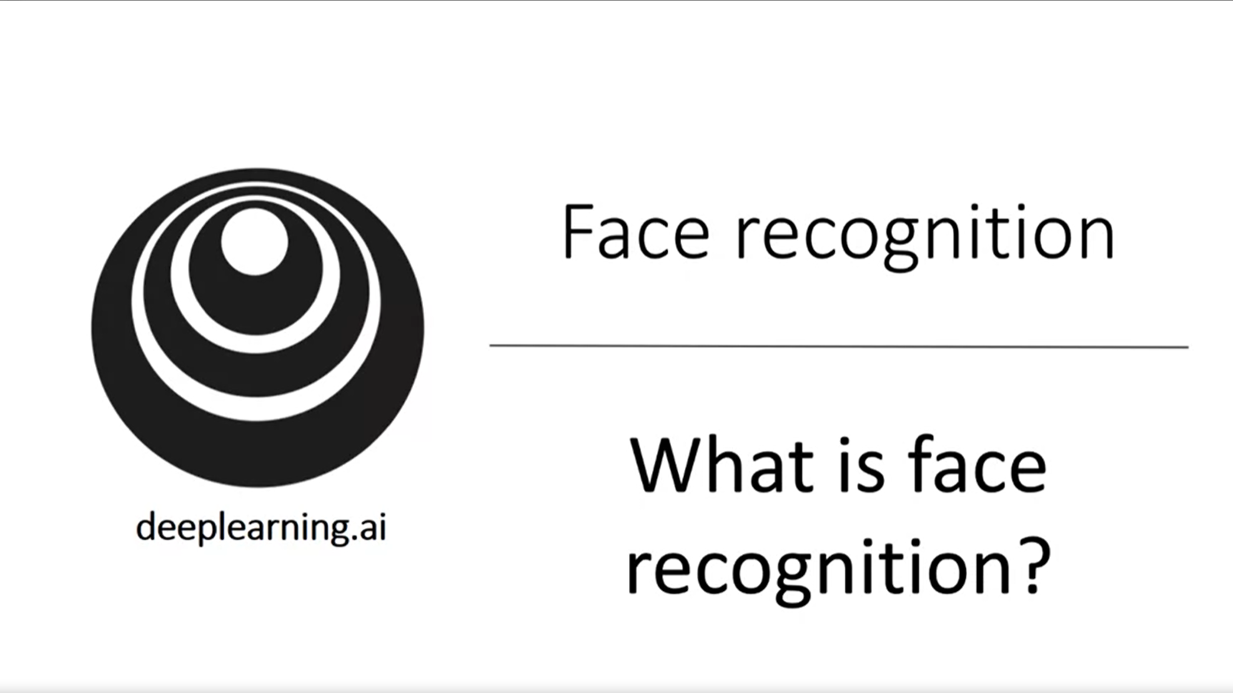

This week we will look at some important special applications for convnets.

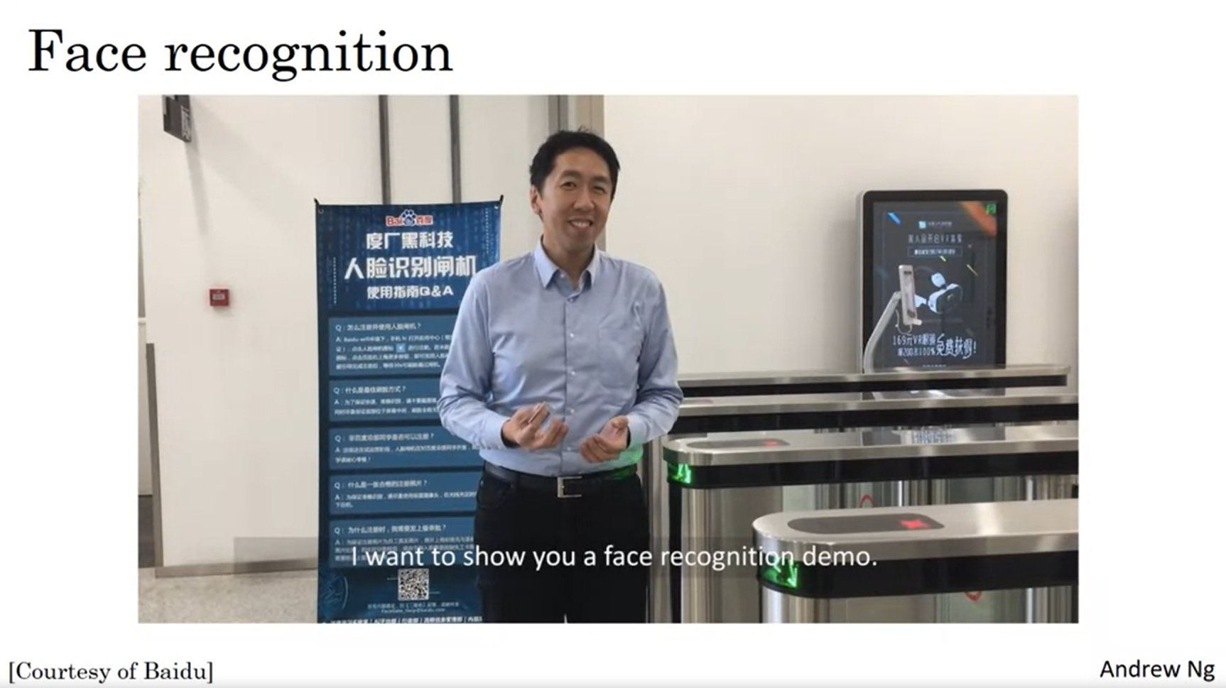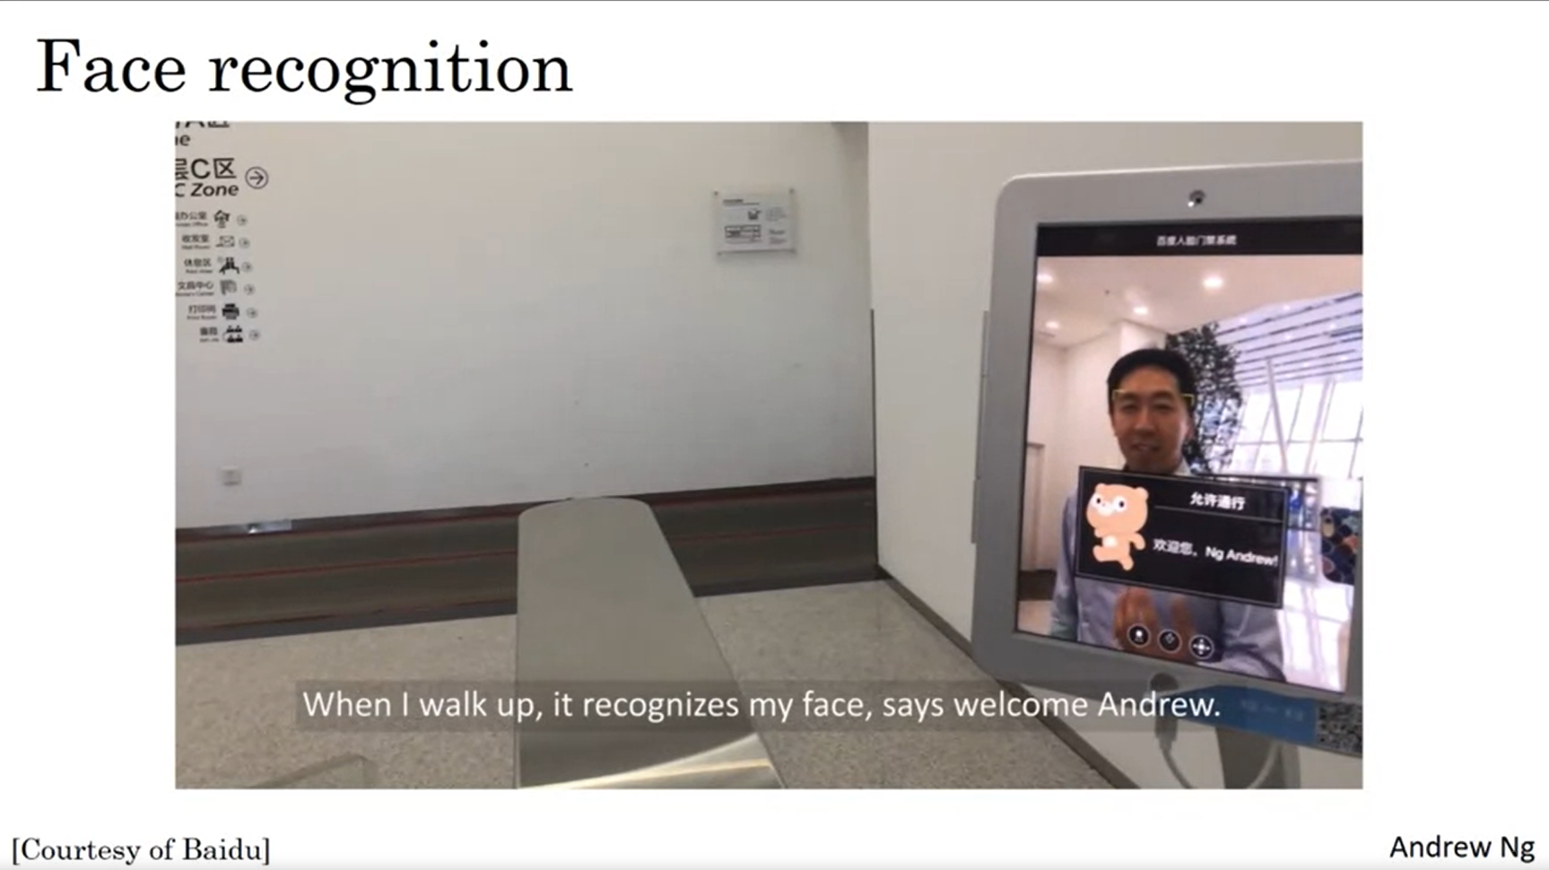

Instead of Ids to enter a building, face recognition can be used.

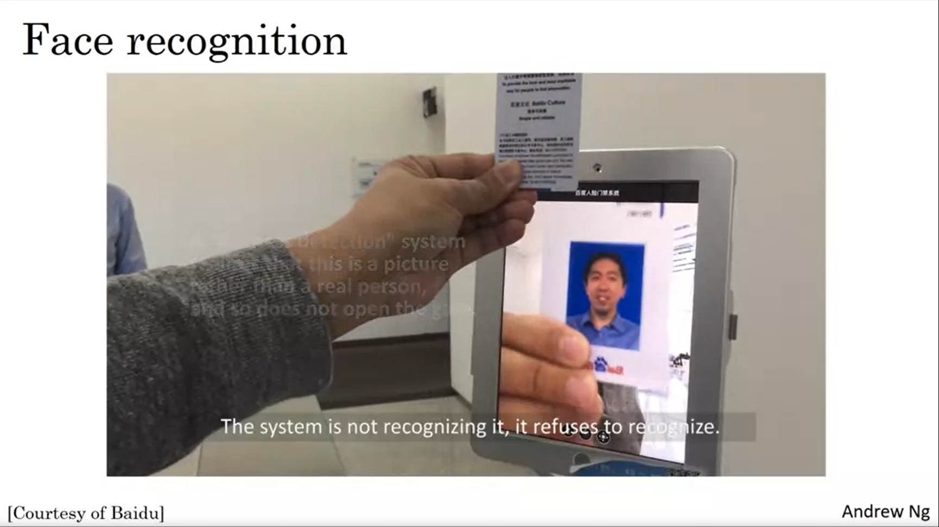

It cannot be tricked using the badge (“Liveness detection”).

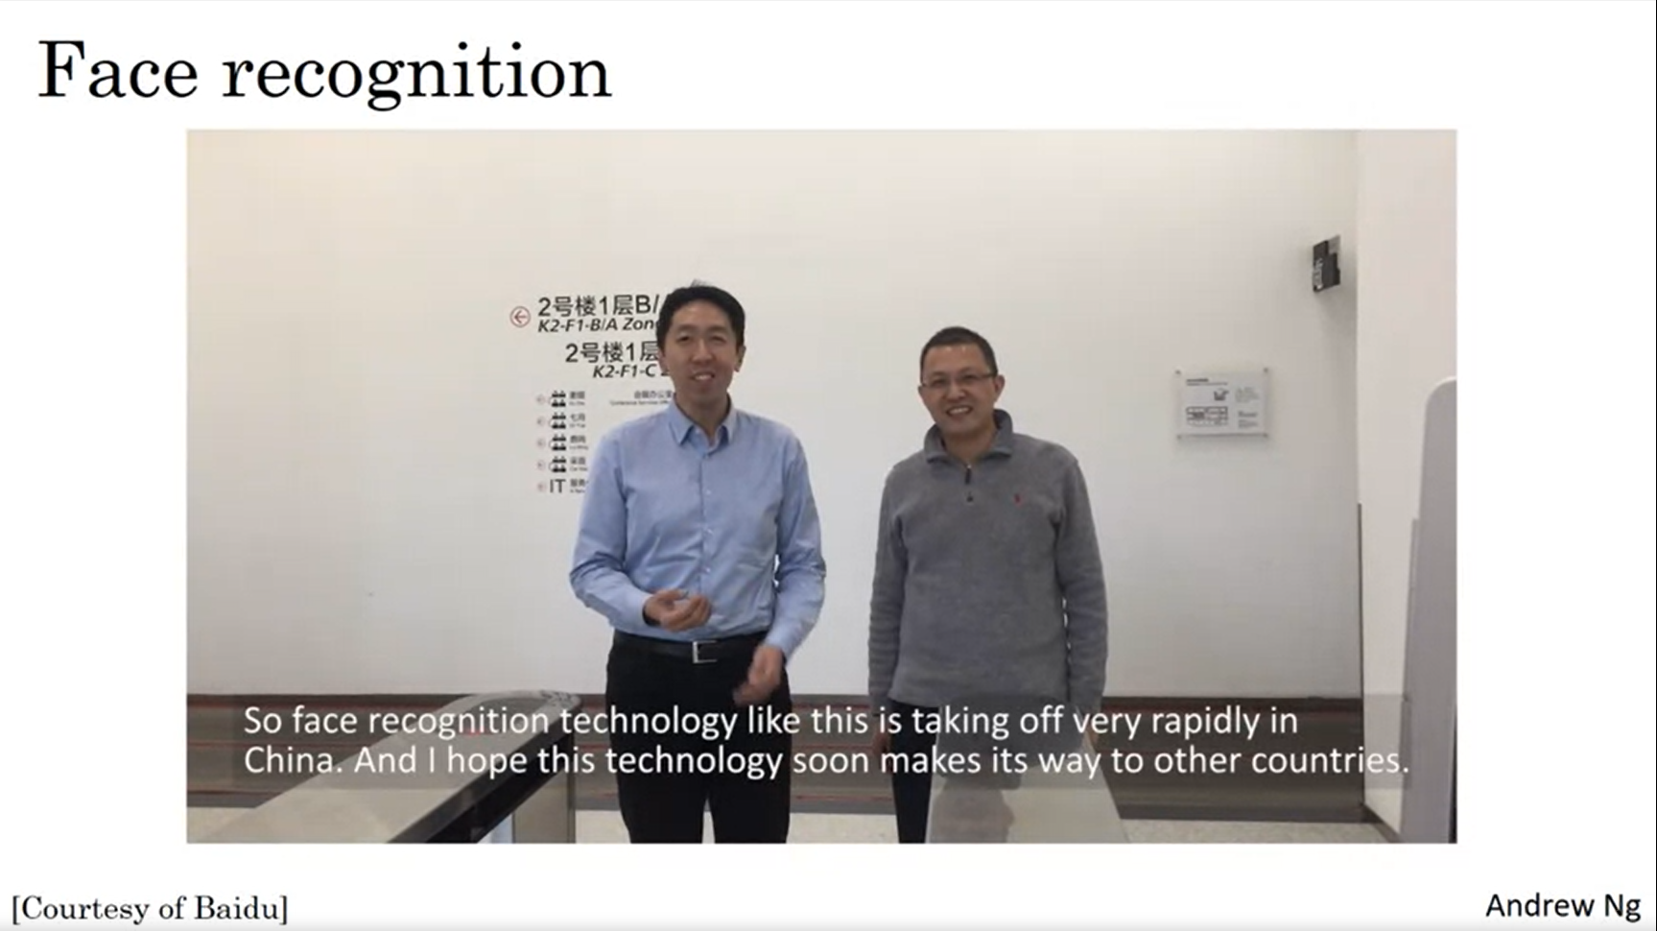

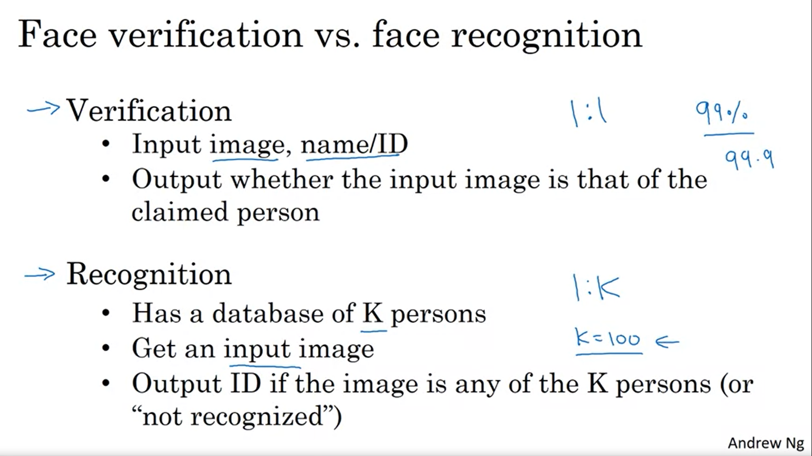

Face verification is a 1:1 problem. Face recognition is much harder.

You will need a face verification system with an accuracy of > 99% to use it for face recognition to still have a high chance to get it correct.

One of the reasons why it is difficult is that it is a one-shot learning problem.

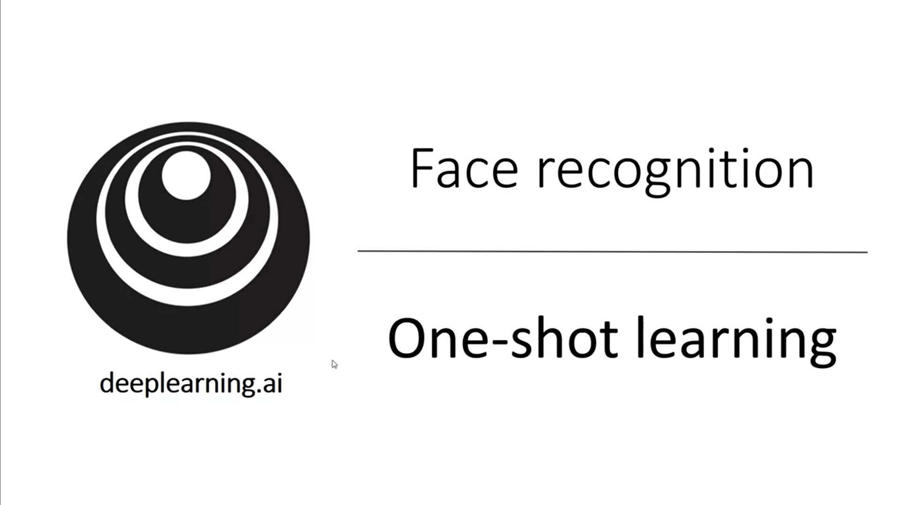

What does one-shot learning mean?

You need to recognize a person given just one single example / image. Historically, deep learning algorithms do not work well when you have only one training example.

How to address this problem?

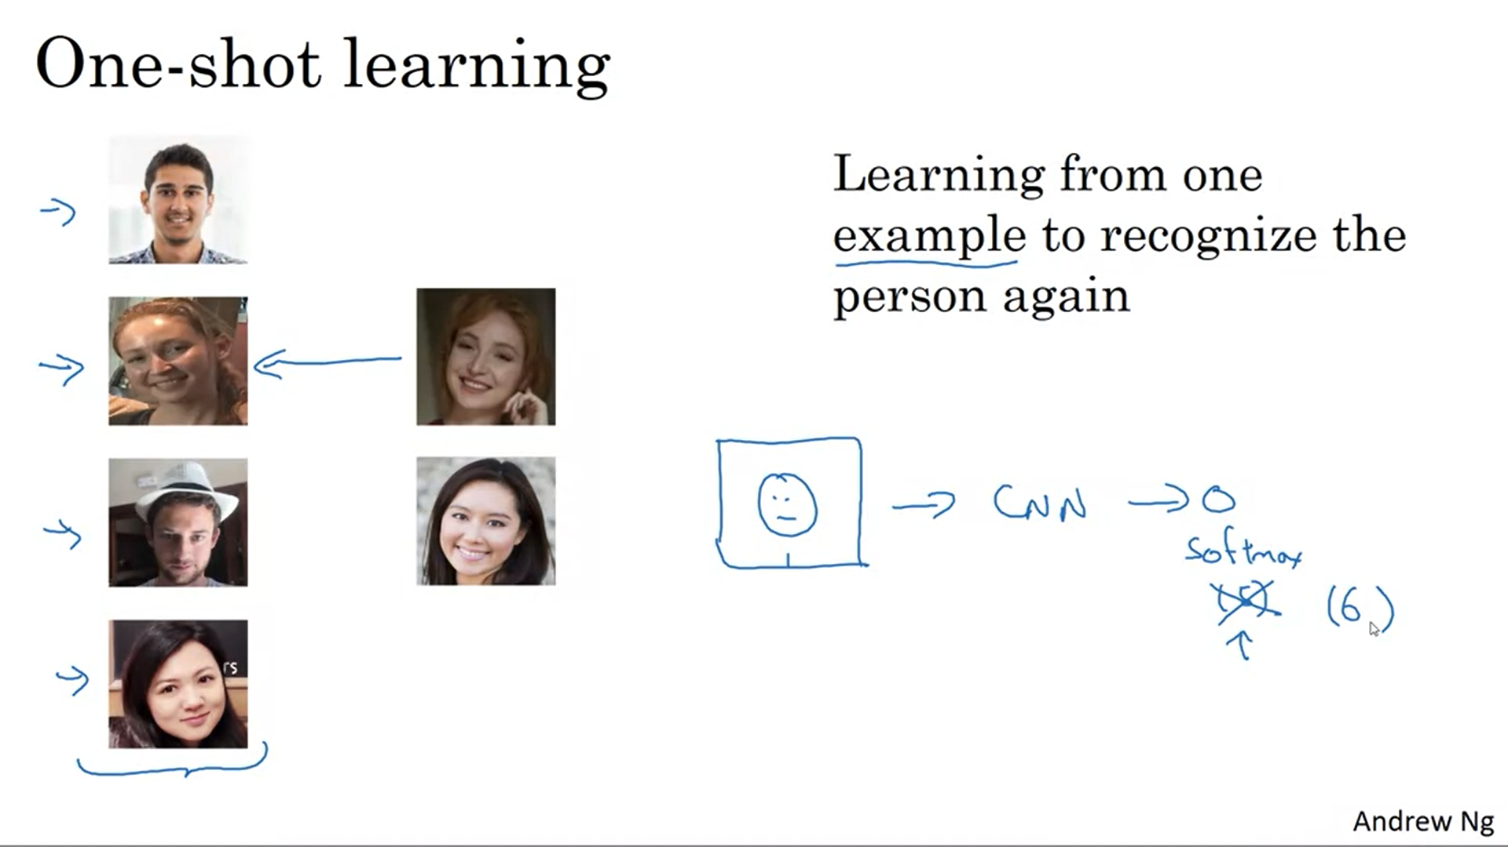

One possible approach is taking the image, feeding it to a convnet, softmax with 5 outputs (4 for each of the persons and 1 for none). But this really does not work well. In addition, what if your team grows to 5 people? Do we have to retrain the convnet every time? There is a better approach…

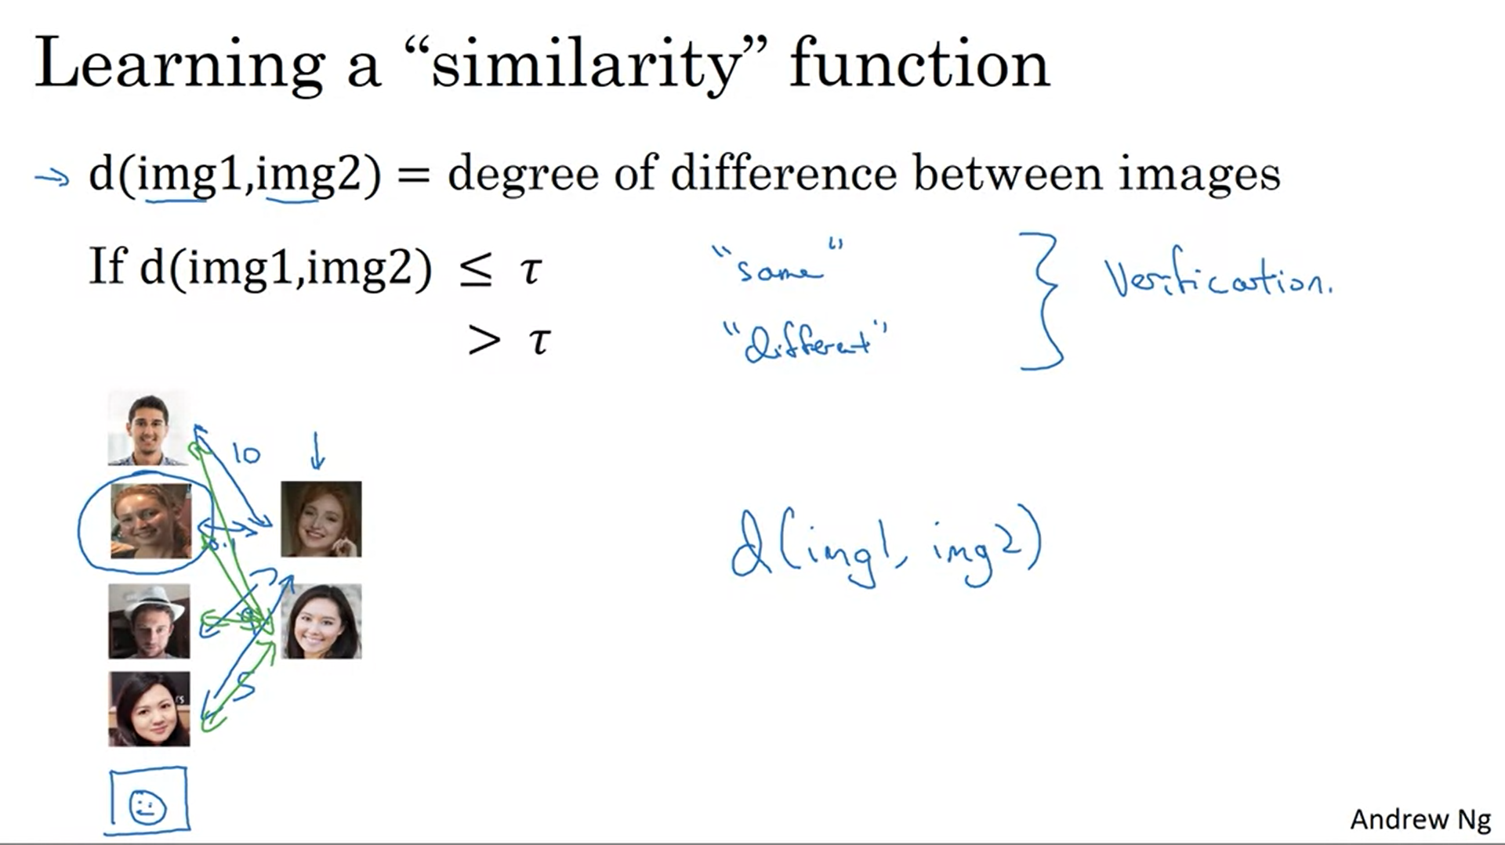

Tau is a hyperparameter. Using the similarity function you can solve the verification problem.

For the recognition task, you will use the function to compare the test image with each image from the database.

If the difference is large to each of the persons in the database, then you can say that the person is not in the database.

This allows to solve the one-shot learning problem.

You can just add a new person to the database and it works fine.

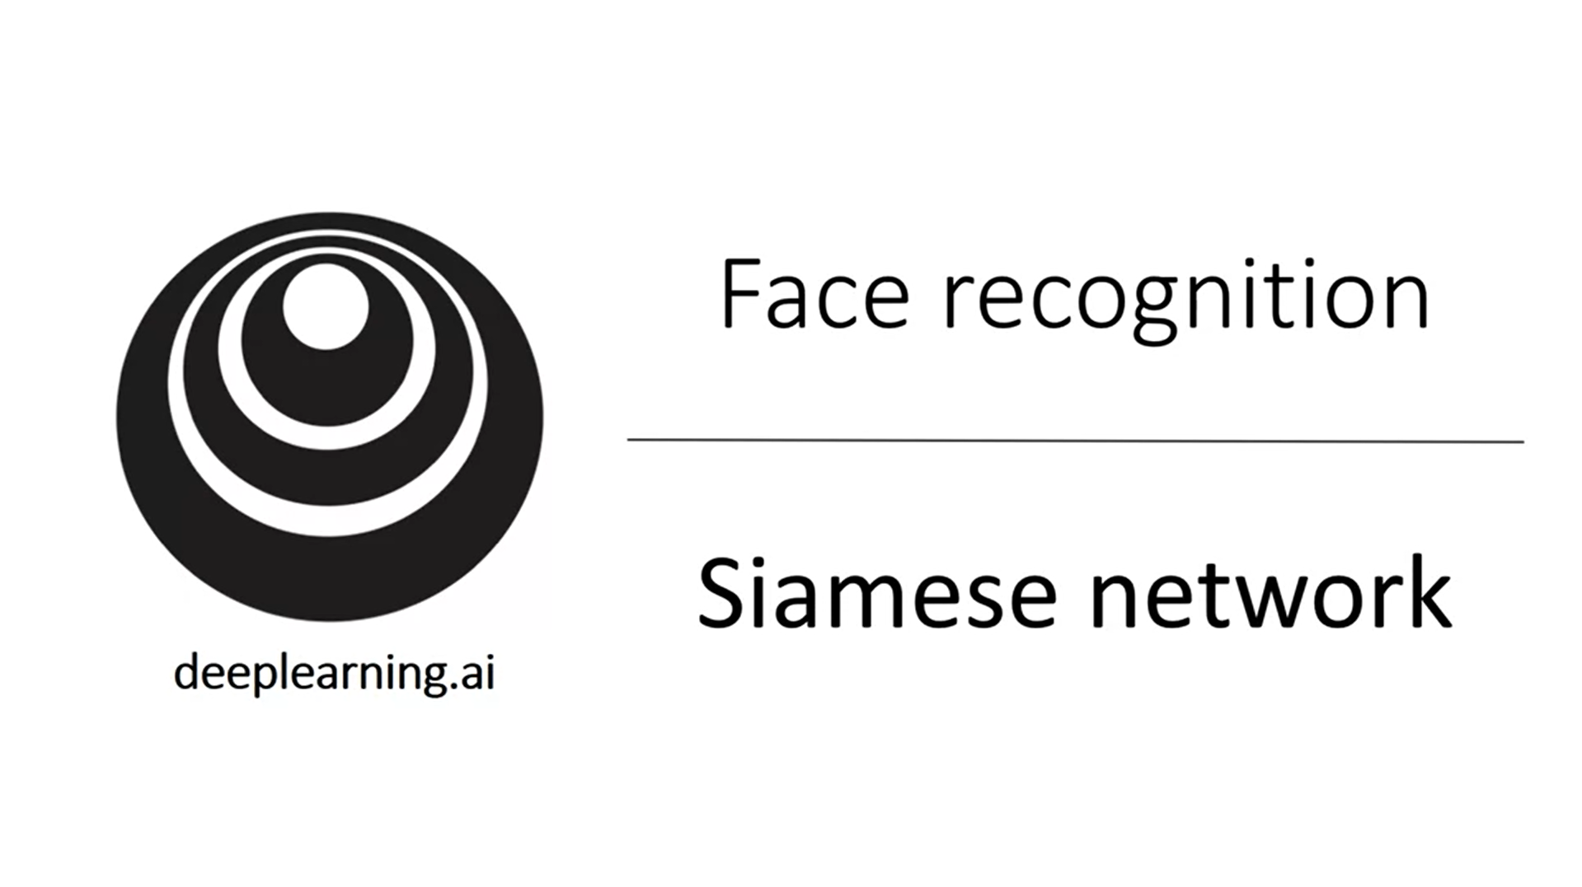

How to train the neural network to learn the function d? The job is to input two images and determine how different they are. A good way to do this is a Siamese network.

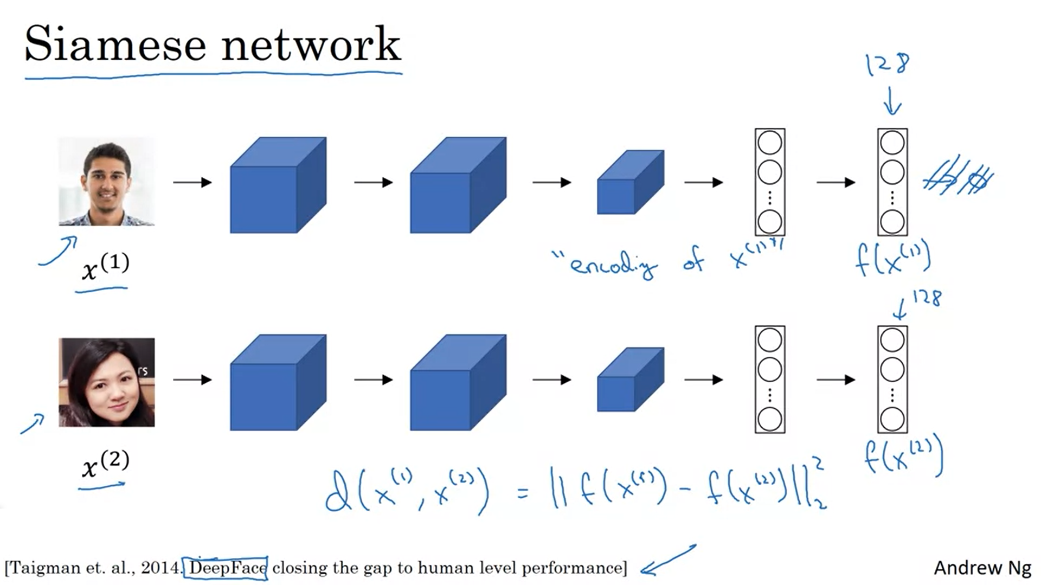

We will not use an output softmax layer. Instead we will use the 128 numbers encoding.

We will feed the second image to the same network with the same parameters and get a different encoding.

The norm of the difference between the encodings is the similarity function.

So the idea is to run two inputs through the identical neural network and compare the output encodings.

The ideas come from the research system DeepFace.

How to train the networks’ parameters?

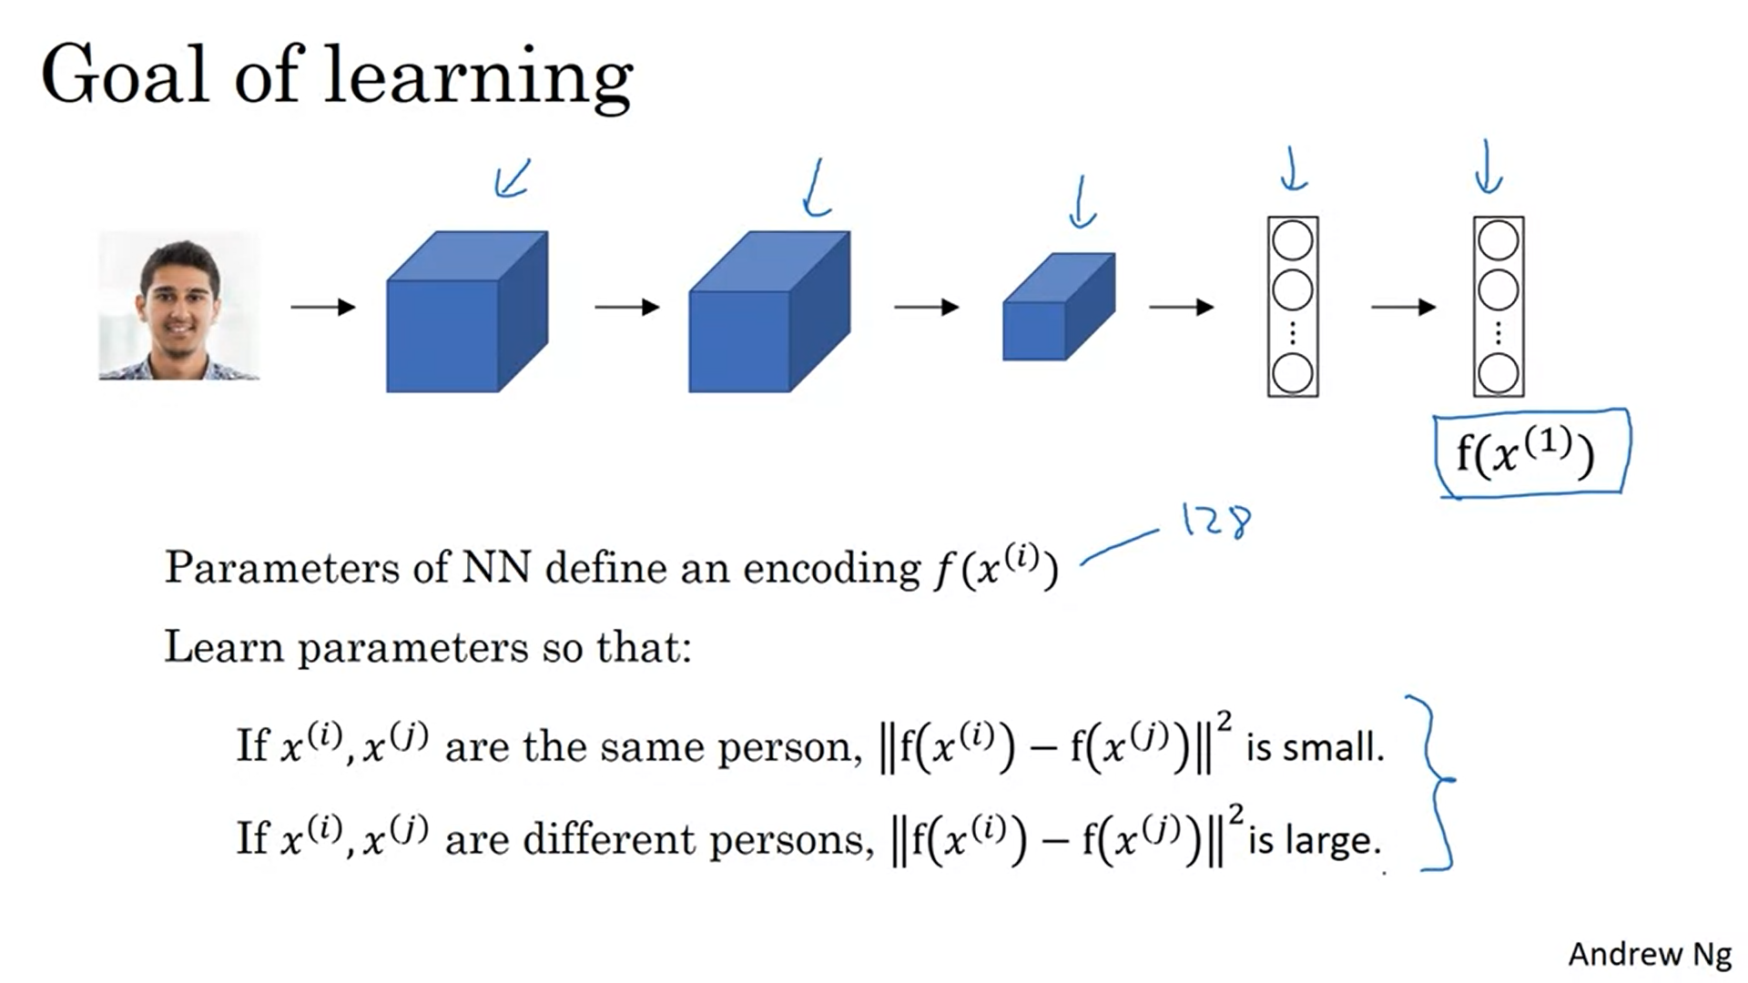

Use backpropagation to vary all parameters to make sure that these conditions are satisfied.

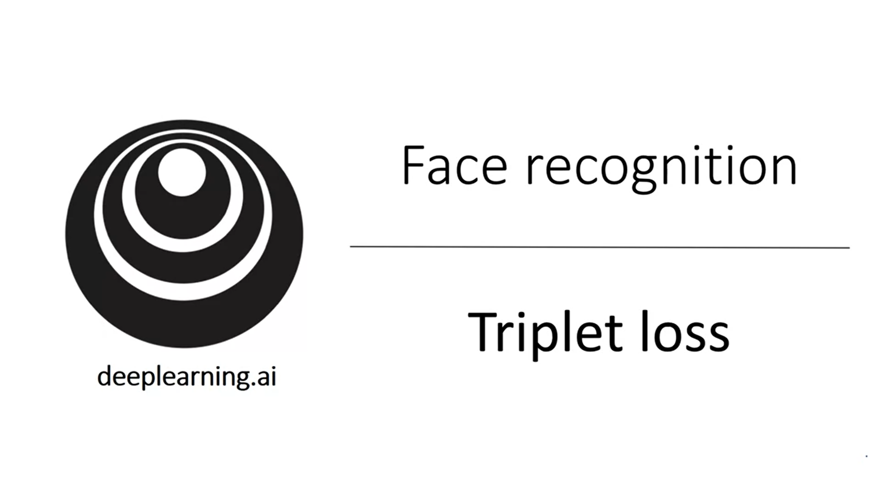

How to actually define an objective function so that the neural network will learn what we discussed in the previous video. We can do that using the triplet loss function.

Apply gradient descent using the triplet loss.

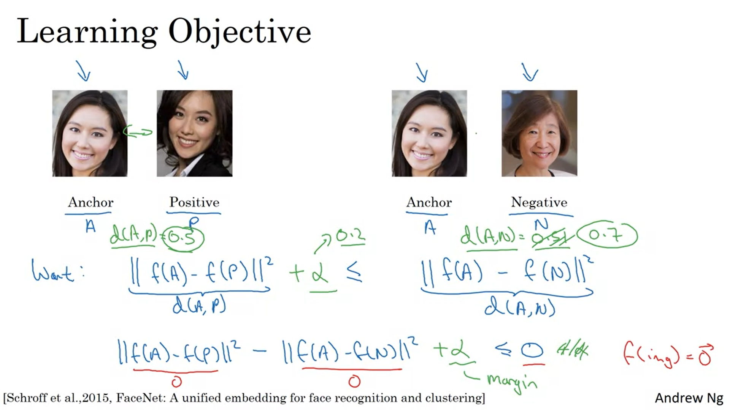

Compare pairs of images (several images at the same time).

You have one anchor image, one positive image (same person) and one negative image (that’s where the name triplet comes from).

We want the difference between the anchor and the positive image to be smaller than the difference between the anchor and the negative image.

Problem: with 0 outputs for all encodings (or other identical outputs) the condition would be fulfilled. That is why we modify the objective and add the alpha hyperparameter to make sure that the difference is lower by a certain margin. We would then not be satisfied if the difference is just a bit smaller. There needs to be the gap of alpha at least.

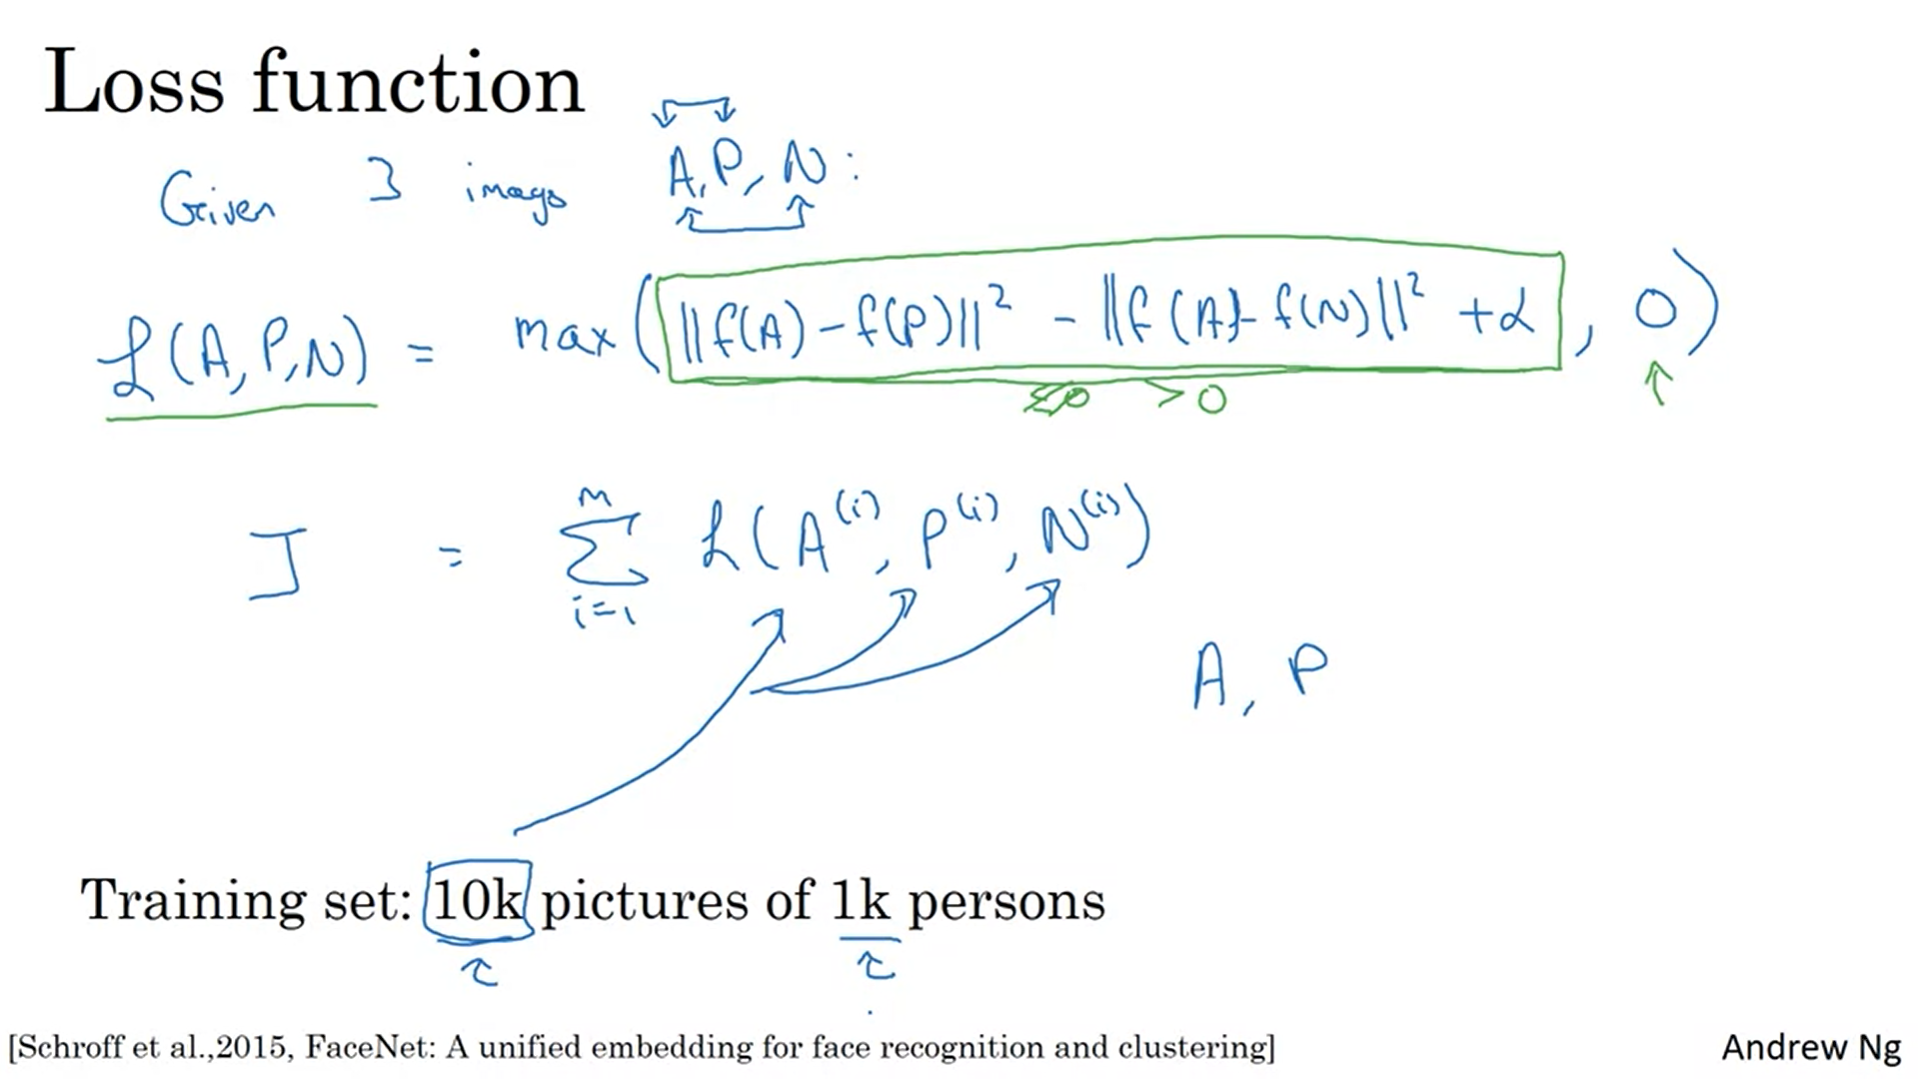

Let’s formalize the triplet loss function. The neural network tries to get the green term below 0. It doesn’t care how much below 0.

Take 10k pictures to select triplets and train the network using the triplet loss function and gradient descent.

You will need pairs of pictures for a person. It does not work if you have only 1 picture per person. But once the network is trained you can apply it to the one shot learning problem.

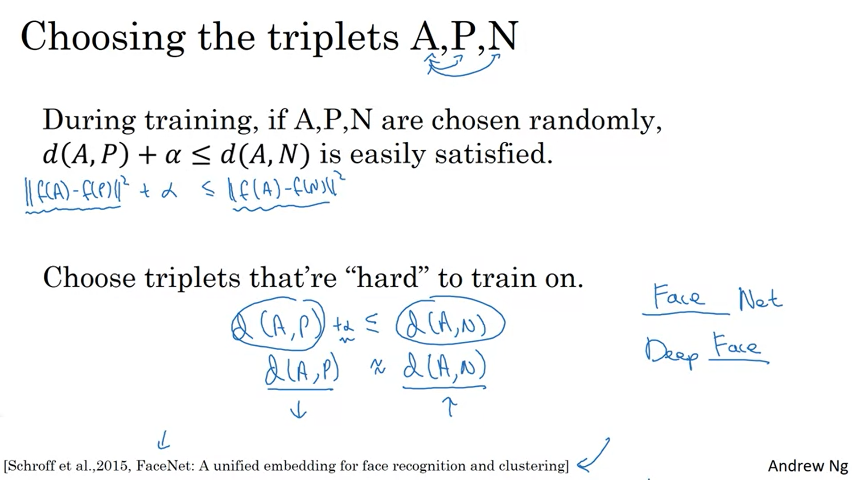

Choosing the triplets strategically improves the computational cost of the algorithm.

If you choose randomly, gradient descent might not do much because if the condition is already satisfied no parameters will be updated.

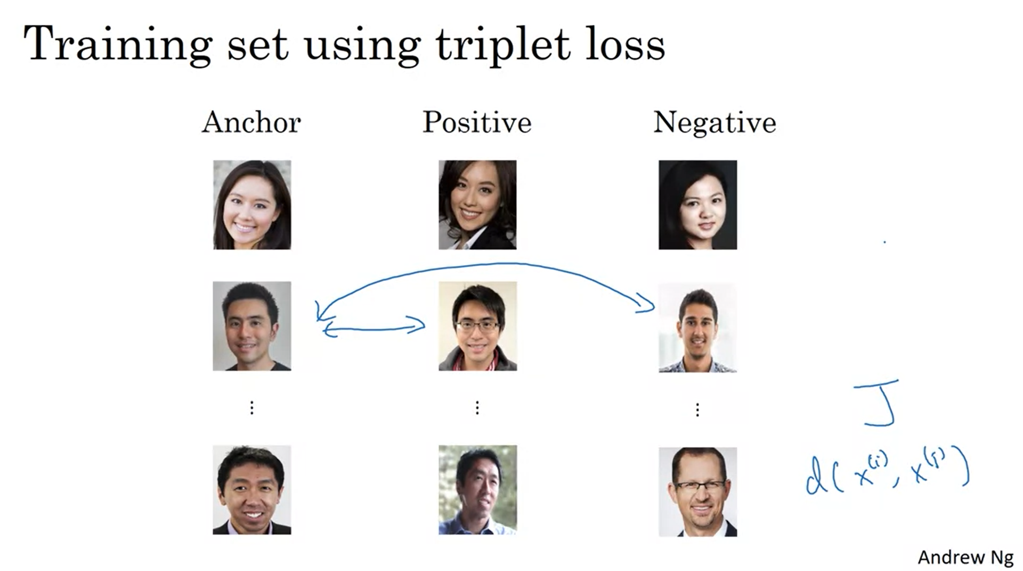

Map the training set to triples. Minimize the cost function J. Backprop will adjust the parameters.

Commercial face recognition systems are trained on lots of data (10M to >100M). There are open source implementations so this is a domain for just using existing systems!

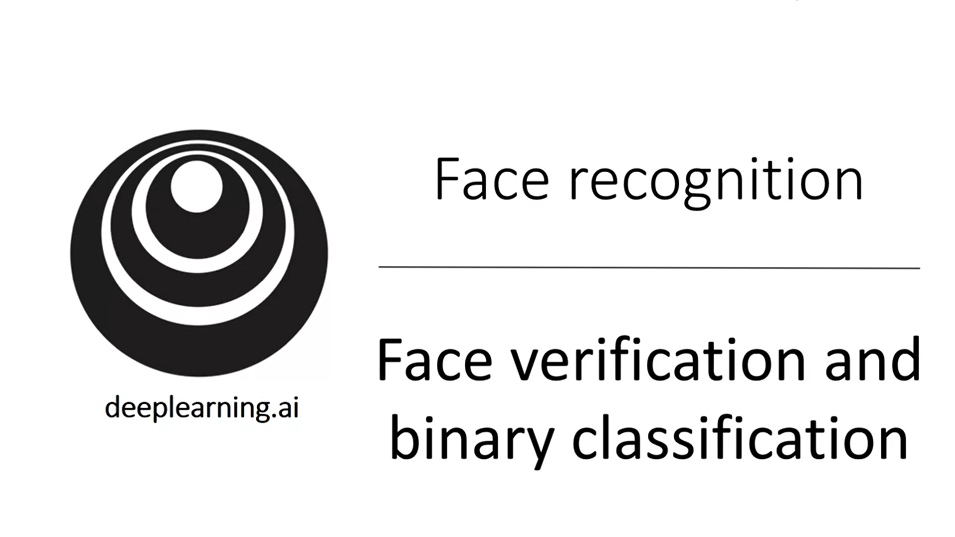 There is another way to learn parameters for the face recognition problem.

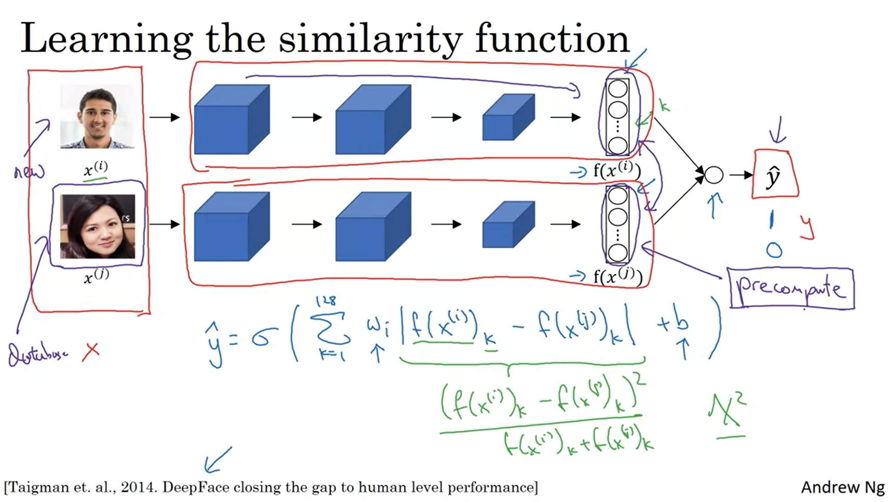

Add a logistic regression unit as target output. This will be 1 when the images are from the same person and 0 when they are not (alternative to triplet loss).

We can take the difference of the encodings to feed them in the sigmoid function. K refers to the kth component of the vector (element-wise absolute difference).

There are other variations of this formula (e.g. the green one -> chi-squared similarity).

This is a siamese network, meaning that the networks share the same parameters.

The purple part can be precomputed for images that are in the database. The encodings do not need to be recomputed for all the employees of the company. This works for both Siamese networks with binary classification and with the triplet loss.

